**Software Requirements**

**Specification**

**Product selling website**

**Prepared by:**

Shobhit Dixit

1702913105

Bachelor of Technology in Information Technology

Semester:4 (B)

KIET Group of Institutions, Ghaziabad

**ABSTRACT**

Shopping cart is a very important feature used in e-commerce to assist people making purchases online, similar to the US English term ‘shopping cart’. The business-to-consumer aspect of electronic commerce (e-commerce) is the most visible business use of the World Wide Web. The primary goal of an e-commerce site is to sell goods and services online. E-commerce is fast gaining ground as an accepted and used business paradigm. Moreand more business houses are implementing web site providing functionality for performing commercial transactions over the web. It is reasonable to say that the process of shopping on the web is becoming common place.

Shopping Cart is a very important feature used in e-commerce to assist people making purchases any products online. This project deals with developing an e-commerce website for online different types of products. It provides the user with a catalog of different types of products available for purchase in the store. In order to facilitate online purchase a shopping cart is provided to the user. The system is implemented using a 3-tier approach, with a backend database, a middle tier of Microsoft Internet Information Services (IIS) andASP.NET, and a web browser as the front end client. The Shopping Cart project has been developed to allow business grows larger and faster. This site will let customers to view and order products online from any part of the world. The site sells different types of. Under this website many products and services can be ordered. The Shopping Cart is expanded permanently through new products and services in order to offer a product portfolio corresponding to the market. Private customer and business customers can order the selected products of the

Shopping Cart Service online quickly and comfortably. Target groups of customer of the Shopping Cart are huge. The customers can have a payment option through credit card only. In order to use the load writing procedure, the customer registers itself and receives a login for its purchases name. It is an Internet application.

**ACKNOWLEDGEMENT**

Nothing concrete can be achieved without an optimum combination of inspection and perspiation.The idea of presenting this material without adequate thanks to those who give it to us or pointed in the right direction seems simply indefensible.

Generating this piece has been time consuming and an arduous task and has involved

Various contributions.

It is my pleasure to acknowledge the help I have received from different teachers and individual, while making this project.

**TABLE OF CONTENTS**

1. **Introduction**
   1. Purpose……………………………………………………………………………….4
   2. Scope ………………………………………………………………………………...4
   3. Definitions, Acronyms and Abbreviations…………………………………………...4
   4. References……………………………………………………………………………5
   5. Overview……………………………………………………………………………..5
2. **Overall description** 
   1. Product Perspective…………………………………………………………………..6
   2. Product Function…………………………………………..........................................6
   3. User Classes and Characteristics…………………………………………..................6
   4. User Documentation.………………………………………………………………....6
   5. Design Implementation…………………………………………………………..…...7
   6. Operating Environment…………………………………………................................7
   7. Analytics……………………………………………………………………………..7
   8. Assumptions and Dependencies
3. **Specific Requirements**
   1. Functional Requirements…………………………………………………………......8
   2. Non-Functional Requirements……………………………………………..………..10
      1. Performance…………………………………………..........................................10
      2. Security…………………………………………..................................................10
      3. Reliability……………………………………………………………………..…11
      4. Maintainability………………………………………………………………..…11
      5. Constraints…………………………………………………...………………..…11
4. **Interfaces and Possible Scenarios**
   1. Customer’s Interface………………………………………………………………..11
      1. Login………………………………………………………………………….…11
      2. Registration Interface……………………………………………………………12
      3. Personal Data Editing……………………………………………………………12
      4. Search……………………………………………………………………………12
      5. Add as favorites………………………………………………………………….12
      6. Cart………………………………………………………………………………12
      7. Payment………………………………………………………………..………...12
      8. Support………………………………………………………………………......13
   2. Interfaces for Shop Owner………………………………………………...………...13
   3. Interfaces for Sales Manager…………………………………………………...…...13
   4. Interfaces for Accounts Manager…………………………………………………...14
   5. Interfaces for Purchase Manager………………….………………………………...14
   6. Interfaces for Customer care………………………………………………………...14
   7. Interface for Administrator…………………………………………………..……...14
5. **Database Design**
   1. Database Table Design………………….……………………………………………..15
      1. Category Design………………….…………………………………………...…15
      2. Product Table………………….…………………………………………………15
      3. Seller Login Table ………………….……………………………………………16
      4. Login Table………………….…………………………………………………..16
      5. Store Table………………….……………………………………………………16
      6. Temp Table………………….………………………………………………...…16
      7. User Table………………….………………………………………………...….17
      8. Feedback Table………………….……………………………………………….17
      9. Account Table………………….………………………………………………..17
      10. Order Table………………….………………………………………………...…17
6. **Unified Modelling Language**
   1. Use Case Diagram………………….…………………………………………………18
   2. Sequence Diagram…………………………………………………………………...18
   3. Class diagram………………………………………………………………………....19
   4. Activity Diagram….………………………………………………………….………20
   5. Collaboration Diagram……………………………………………………….………22

**1. INTRODUCTION**

The introduction of the Software Requirements Specification (SRS) provides an overview of the entire SRS with purpose, scope, definitions, acronyms, abbreviations, references and overview of the SRS.

**1.1. Purpose**

The purpose of the document is to collect and analyze all assorted ideas that have come up to define the system, its requirements with respect to consumers. Also, we shall predict and sort out how we hope this product will be used in order to gain a better understanding of the project, outline concepts that may be developed later, and document ideas that are being considered, but may be discarded as the product develops.

In short, the purpose of this SRS document is to provide a detailed overview of our software product, its parameters and goals. This document describes the project's target audience and its user interface, hardware and software requirements. It defines how our client, team and audience see the product and its functionality. Nonetheless, it helps any designer and developer to assist in software delivery lifecycle (SDLC) processes

**1.2. Scope**

This Document plays a vital role in the development life cycle (SDLC) and it describes the complete requirement of the system. It is meant for use by the developers and will be the basic during testing phase. Any changes made to the requirements in the future will have to go through formal change approval process.

This SRS is also aimed at specifying requirements of software to be developed but it can also be applied to assist in the selection of in-house and commercial software products. The standard can be used to create software requirements specifications directly or can be used as a model for defining a organization or project specific standard. It does not identify any specific method, nomenclature or tool for preparing an SRS.

**1.3. Definitions, Acronyms, and Abbreviations**

|  |  |
| --- | --- |
| HTML | (Hyper Text Mark-up Language): It is used to create static web pages. |
| DB2 | (IBM Database 2): It is a database management system that provides a flexible and efficient database platform to raise a strong "on demand" business applications. |
| HTTP | (Hyper Text Transfer Protocol): It is a transaction oriented client/ server protocol between a web browser and a web server. |
| GUI | Graphical User Interface |
| FAQ | Frequently Asked Questions |
| XML | (Extensible Mark-up Language): It is a mark-up language that was designed to transport and store data. |
| CRM | Customer Relationship Management |
| RAID 5 | Redundant Array of Inexpensive Disk/Drives |
| Web 2.0 | It is commonly associated with web applications which facilitate interactive information sharing, interoperability, user-centred design and collaboration on the World Wide Web |
| CRM | Customer Relationship Management |
| DFD | Data Flow Diagram |

* 1. **References**

The following websites are referred:

* Linkedin
* W3school
* E-Store Structural Model
  1. **Overview**

The remaining sections of this document provide a general description, including characteristics of the users of this project, the product's hardware, and the functional and data requirements of the product.

Overall description of the project is discussed in section 2 of this document.  Section 3 gives the functional requirements, data requirements and constraints and assumptions made while designing the E-Store.  It also gives the user viewpoint of product.  Section 3 also gives the specific requirements of the product.  Section 3 also discusses the external interface requirements and gives detailed description of functional requirements. Section 4 is for supporting information..

1. **OVERALL DESCRIPTION**

**2.1. Product Perspective**

Online website based e-commerce is an outstanding way of bringing customers on an online platform to make purchase in a secured and efficient manner irrespective of distance between the two. Website offers daily recommendations for discounts and offers on products based on their category.

* 1. **Product Function**
* Provide a simple interface and platform to ease the process of buying products online.
* Include smooth functionality and efficiency that adds to buyers’ confidence.
* Appropriate space is dedicated to its Offers zone and deal of the day that fetches adequate attention of users.
* Website keeps a constant focus on new category creation and expansion of products.
* Ads and promotion activities motivate shoppers to buy online.
* Tracking feature of orders and pending deliveries for both sellers and buyers.
* Notifying order and delivery reports to customers and sellers.
  1. **User Classes and Characteristics:**

**2.3.1. Customer** - He or she is a verified user of website who is intended to buy a product from the seller via the website platform. The customer must have a username and password to make a purchase. The person is regularly updated and fed with latest offers and discounts according their interest.

**2.3.2. Seller -** He or she is a verified person who is allowed to sell items over the platform. Seller’s details are stored on database and all the products are listed under him that he is ready to sell or are available. He is responsible to set products details, price, and quantity.

**2.3.3. Administrator -** He or she is responsible for monitoring functions and procedures on platform. Administrator is responsible to provide valid information of a purchase to the concerned authority in case of any dispute between the customer and seller or in case of exchange.

* 1. **User Documentation**
* Notifications
* Contact Us
* User Agreement
* Select the operator
* Make A Payment
* Submit Account Details
* Payment Security
* Privacy Policy
  1. **Design Implementation**

The user interface shall be implemented using any tool or software package like Java Applet, MS Front Page, Enterprise Java-Beans (EJB) etc. on following languages.

Client-side Programming Language:

* JavaScript: JavaScript is a lightweight, object-oriented, cross-platform scripting language, mainly used within web pages.
* HTML5: HTML5 is the fifth revision of the HTML standard.
* CSS: Cascading Style Sheets define style rules in a separate CSS file.
  1. **Operating Environment**

Recommended browsers are Chrome, Firefox, Safari and Internet Explorer 8 or higher.

|  |  |  |
| --- | --- | --- |
| **Particulars** | **Client System** | **Server System** |
| **Operating System** | Windows/Linux/Android/iOS | Linux |
| **Processor** | Intel or AMD | Intel or AMD |
| **Hard Disk** | 1 GB | 1 TB |
| **RAM** | 256 MB | 8 GB |

* 1. **Analytics**

Analytics are required in order to monitor and analyse the requirements details from customers.

* Structured Data Formats**:** The Open Graph protocol, originally developed by Facebook, is an RDF a-based format that enables any web page to become a rich object in a social graph.
* Google Analytics: Google Analytics is a free service to get detailed statistics about the visitors of a website, provided by Google.
  1. **Assumptions and Dependencies**
* The customer and seller must have basic knowledge of computers and English language.
* Each User must have a User ID and password.
* Each Seller must have Seller ID and password.
* There must be an Administrator.
* Internet connection is a must.
* Proper browsers should be installed in the user’s system.

1. **SPECIFIC REQUIREMENTS**

**3.1. Functional Requirements**

This subsection contains the requirements for the e-store. These requirements are organized by the features discussed in the product functions. Features from there, they are then refined into use case diagrams and to sequence diagram to best capture the functional requirements of the system.

**3.1.1. Provide Search facility**

* User to enter the search text on the screen and display matching products based on the search.
* Enable user to select multiple options on the screen to search.
* Display only 10 matching result on the current screen.
* Enable user to navigate between the search results.
* Notify the user when no matching product is found on the search.

**3.1.2. Tailored Content for the User**

* Using the cookies of the user to study the buying pattern of the user.
* Assists him in his purchase and customizes his homepage according to his previous interactions.
* Including additions to his wish-list, page views, previous searches, reviews about the product among other things.
* Making good use of data is imperative to designing great customized user experiences.

**3.1.3. Displaying Related Items**

* Including results for related items to the items already bought.
* This can incentivize the customer to purchase more.
* By tracking the buying pattern of the user who is logged in, system recommends similar items for the user
* Display similar products with high ratings newly in-stock or are featured at special discount prices.
* Displaying all related items that other users purchased in addition to that product.
* This exposes the user to a larger variety of items of his interest.

**3.1.4. Create Sellable items on website**

* Provide an interface to all the sellers to add product description and price through their account.
* List all the sellers for a common product they offer to sell and prioritize them based on percent of discount.

**3.1.5. Easy Return or Exchange**

* The system allows customers to return the item back to the seller in case he or she doesn’t like the product and get the feedback of customer .
* The system allows customer to exchange the product with seller in case of delivery of any defective item and get feedback from customer.
* Notify seller about the customer’s reason and feedback about the product.

**3.1.6. Provide personalized profile**

* The seller’s and customer’s profile contain all details of seller and customer respectively like contact, location, address and seller’s license.
* To display both the active and completed order history in the customer profile.
* To allow user to select the order from the order history and detailed information.
* To display the most frequently searched items by the user in the profile.
* To help seller keep list of products and its information in its profile.

**3.1.7. Move transaction money and details to Profile**

* Safe transfer of money into seller’s bank account after successful transaction of money.
* Add details of transfer of money to company’s selling and purchasing events logs and database.
* Send an order confirmation to the user and seller about the purchase through email or SMS.

**3.1.8. Detailed invoice for Customer and Seller**

* The system shall display detailed invoice for current order once it is confirmed.
* The system shall allow user to print the invoice.
* The system shall display detailed information of seller’s detail to customer as well as customer’s detail to seller.

**3.1.9. Provide shopping cart facility**

* The system shall provide shopping cart during online purchase.
* The system shall allow user to add/remove products in the shopping cart.
* Later customer can confirm orders for purchase.

**3.1.10. Online tracking of shipments**

* The system shall allow user to enter the order information for tracking.
* The system shall display the current tracking information about the order
* The system notifies seller about delivery of product to the consumer.

**3.1.11. Allow multiple payment methods**

* The system shall display available payment methods for payment.
* The system shall allow user to select the payment method for order.

**3.1.12. Provide Customer Support.**

* The system shall provide online help, FAQ’s customer support, and sitemap options for customer support.
* The system shall allow user to select the support type he wants.
* The system shall allow user to enter the customer and product information for the support.
* The system shall display user contact of seller and website support desk
* The system shall display the online help upon request.
* The system shall display the FAQ’s upon request.

**3.2. Non-Functional Requirements**

**3.2.1. Performance**

* The product shall be based on web and has to be run from a web server.
* The product shall take initial load time depending on internet connection strength which also depends on the media from which the product is run.
* The performance shall depend upon hardware components of the client/customer.

**3.2.2. Security**

**3.2.2.1. Data Transfer**

* The system shall use secure sockets in all transactions that include any confidential customer information.
* The system shall automatically log out all customers after a period of inactivity.
* The system shall confirm all transactions with the customer’s web browser.
* The system shall not leave any cookies on the customer’s computer containing the user’s password or confidential information.

**3.2.2.2. Data** **Storage**

* The customer’s web browser shall never display a customer’s password. It shall always be echoed with special characters representing typed characters.
* The customer’s web browser shall never display a customer’s credit card number after retrieving from the database. It shall always be shown with just the last 4 digits of the credit card number.
* The system’s back-end servers shall never display a customer’s password. The customer’s password may be reset but never shown.
* The system’s back-end servers shall only be accessible to authenticated administrators.
* The system’s back-end databases shall be encrypted and within company’s perimeter.

**3.2.3. Reliability**

* The system provides storage of all databases on redundant computers with automatic switchover.
* The reliability of the overall program depends on the reliability of the separate components.
* The main pillar of reliability of the system is the backup of the database which is continuously maintained and updated to reflect the most recent changes.

**3.2.4. Safety**

* It is the state of being "safe", the condition of being protected against physical, social, spiritual, financial, political, emotional, occupational, psychological, educational or other types or consequences of failure, damage, error, accidents, harm or any other event which could be considered non-desirable.
* This can take the form of being protected from the event or from exposure to something that causes health or economical losses.
* It can include protection of people or of possessions.

**3.2.5. Maintainability**

* A commercial database is used for maintaining the database and the application server takes care of the site.
* In case of a failure, a re-initialization of the program will be done.
* Also the software design is being done with modularity in mind so that maintainability can be done efficiently

**3.3. Constraints**

* Limited numbers search queries for the users. Servers incapable of handling high traffic burst
* The actual product might differ from its display image. Uniform quality of service is not ensured.
* It cannot ensure the reliability of the review.
* The User and Seller must have confirmed User ID and Seller ID respectively.

1. **INTERFACES POSSIBLE SCENARIOS**

**4.1. Customer’s Interface:**

**4.1.1. Login**

This interface will consist of two compulsory fields namely, “User Name” and “Password”. There will also be options for “New User’s Registration” which will redirect to “Registration” page and a “Forgot Password” option in case a user forgets the password.

If the password entered is correct the Main User Interface opens up else an error message is displayed.

**4.1.2. Registration Interface**

The user will enter his personal details like Name, User Name, Password, Date Of Birth, Address, Registration Type, etc.

Users will be warned about any mistakes on data format or any other constrains by validation notes and error messages.

When the button "save" button is clicked, the server will check if the username or email is already taken and alert the user.

If everything is entered correctly and saved a new user will be created.

**4.1.3. Personal Data Editing**

If any member wants to change his personal information he can enter his profile by clicking on his name at the top right of the main page and he will be directed to the personal details editing page.

**4.1.4. Search**

The customer can enter the type of item he is looking for and the specifications he is interested in them he can click on “Search”. User can also use advanced search for more options. For eg: the user can filter the results basing on various aspects such as size, color , material, brand etc and also they can sort the product display according to their wish (relevance, price in ascending or descending, popularity)

**4.1.5. Add as favourites**

The user can shortlist his/her favourite item as a list for future reference.

**4.1.6. Cart**

This will be a space for the customer where he/she can store the items he/she whishes to buy. The user can also remove items from cart prior to checkout. Once the user decides to buy the items it cart, the user is directed to the payment page for making payment.

**4.1.7. Payment**

The user given options with various modes of payment (online payment through credit/debit cards, via net or mobile banking or cash on delivery) out of which he chooses one. The chose mode of transaction is carried therefore by proper verification and authentication of bank details.

**4.1.8. Support**

The user can contact with the customer care via phone call or via messages. User can ask for an assistance or can give feedback on a particular aspect.

**4.2. Interface for Seller**

The seller will have a different login id using which he can access his account that contains a control panel that allows him to contact the administrator, set up/ maintain shop etc.

This control panel will allow the shop owner to do the following things:

* Request the admin for a permission to set up a shop.
* Set up the catalog for his shop and upload it so that the admin can make it visible in the website.
* Add/Remove items. The corresponding changes will be done in the database by the Admin.
* Create advertisements for his products.
* Generate a sales report.
* Discontinue the shop.

**4.3. Interface for sales manager**

The sales manager will have a different login id using which he can access his account that contains a control panel that allows him to contact the administrator and manage sales.

This control panel will allow the sales manager to do the following things:

* Maintain the product database so that the same or different kinds of products are properly maintained with their unique id, so that when a customer orders a product, the same product gets allocated without causing any inconsistency to the database.
* Generate current order shipping status status and upload it time to time and provide an expected delivery date. In case a user cancels a particular order, the same is taken care of by the sales manager and proper order status is changed and reflected back.
* Promote sales by associating products with offers and discounts.
* Contact the admin.

**4.4. Interface for Accounts manager**

The Accounts manager will have a different login id using which he can access his account that contains a control panel that allows him to contact the administrator and manage various transactions and accounts.

This control panel will allow the Accounts manager to do the following things:

* Keep track of payment transactions differentiated by their unique id and associated with corresponding user and update payment information.
* Contact he bank for account validation.
* Contact Administrator.

**4.5. Interface for purchase manager**

The Purchase manager will have a different login id using which he can access his account that contains a control panel that allows him to contact the administrator and manage various purchases for the warehouse.

This control panel will allow the Purchase manager to do the following things:

* Whenever the stocks in warehouse goes under a critical value, the system alerts the purchase manager about it and he contacts the administrator seeking permission to make a purchase from a particular vendor.
* Contact a vendor for making a purchase.

**4.6. Interface for customer care**

A customer care employee will have a different login id using which he can access his account that contains a control panel that allows him to contact the administrator and manage various queries and feedbacks from the customer.

This control panel will allow a customer care employee to do the following things:

* Read feedbacks from a particular customer and let the administrator know about it.
* Provide solutions to the queries posted by the customer.
* Contact administrator.

**4.7. Interface for Administrator**

The administrator will have a different login id using which he can access his account that contains a control panel that allows him to contact each and every aspect of the system.

This control panel will allow the administrator to do the following things:

* Access and view the customer database.
* Access and view the database of vendors, go through their requests for shop creation and reply them back with acceptance /dismissal of their request.
* Access and view the employee database and manage them.
* Make the catalog (that is visible to the customers), taking the design of corresponding shop owners in consideration .
* Grant/ Reject purchase permit to purchase manager.
* Manage employee salary.
* Contact employees.

1. **DATABASE DESIGN**

A database design is a collection of stored data organized in such a way that the data requirements are satisfied by the database. The general objective is to make information access easy, quick, inexpensive and flexible for the user. There are also some specific objectives like controlled redundancy from failure, privacy, security and performance. A collection of relative records make up a table. To design and store data to the needed forms database tables are prepared. Two essential settings for a database are:

1. Primary key: - The field that is unique for all the record occurrences.

2. Foreign key: - The field used to set relation between tables. Normalization is a technique to avoid redundancy in the tables.

**5.1. Database Table Design**

5.1.1. Category Design

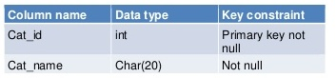

5.1.2. Product Table

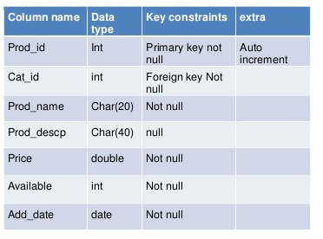

5.1.3. Seller Login Table

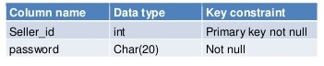

5.1.4. Login Table

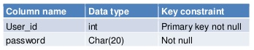

5.1.5. Store Table

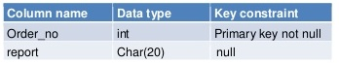

5.1.6. Temp Table

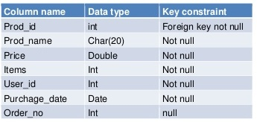

5.1.7. User Table

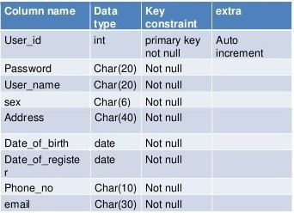

5.1.8. Feedback Table

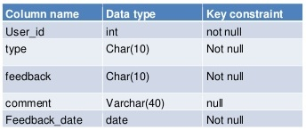

5.1.9. Account Table

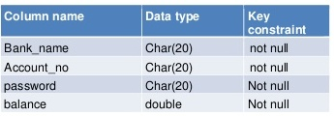

5.1.10. Order Table

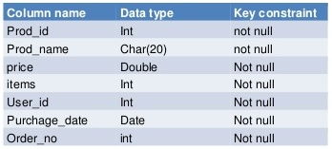

1. **UML DIAGRAMS**

UML is a standard language for specifying, visualizing, constructing, and documenting the artifacts of software systems. UML diagrams are not only made for developers but also for business users, common people, and anybody interested to understand the system. The system can be a software or non-software system. Thus it must be clear that UML is not a development method rather it companies with processes to make it a successful system.

UML is a modeling language used to model software and non-software systems. Although UML is used for non-software systems, the emphasis is on modeling OO software applications. Most of the UML diagrams discussed so far are used to model different aspects such as static, dynamic, etc. Now whatever be the aspect, the artifacts are nothing but objects. If we look into class diagram, object diagram, collaboration diagram, activity diagrams all would basically be designed based on the objects.

**6.1. Use Case Diagram**

The UML provides the use case diagram notation to illustrate the name of the use case actors and relationship between them. User case diagrams are used to model the functional interaction between users and system.

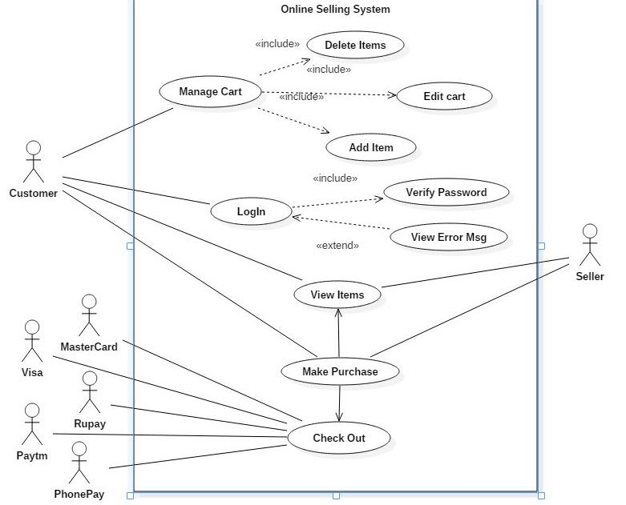

**6.2. Sequence Diagram**

* A sequence diagram illustrates in a kind of format in which each object interacts via messages. It is generalization between two or more specification diagram.
* Sequence diagram is an interaction over view diagram. It provides a big picture over view of now a set of interaction is related in terms of logic and process flow.

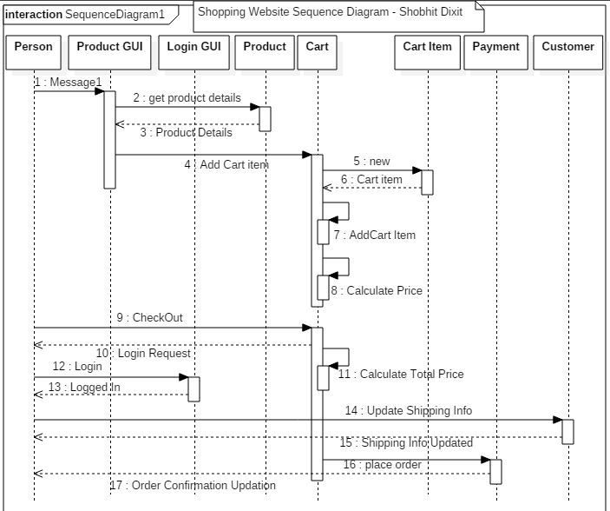

**6.3. Class Diagram**

* Class diagram is a static diagram. It represents the static view of an application. Class diagram is not only used for visualizing, describing, and documenting different aspects of a system but also for constructing executable code of the software application.
* Class diagram shows a collection of classes, interfaces, associations, collaborations, and constraints. It is also known as a structural diagram.

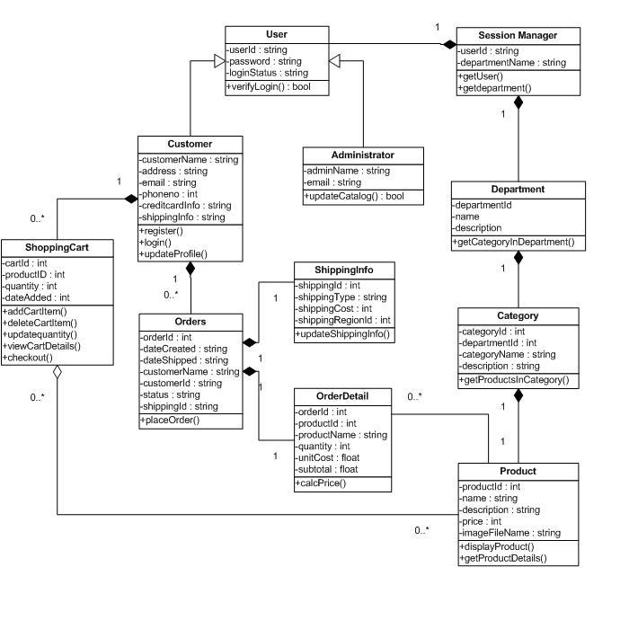

**6.4. Activity diagram**

* The activity diagram used to describe flow of activity through a series of actions. Activity diagram is an important diagram to describe the system. The activity described as an action or operation of the system.
* Activity diagram shows sequential and parallel activities in a process. They are useful for modeling business, workflows, the data flows and complex algorithm.
* A UML activity diagram offers rich notation to flows a sequential of activities. It may be including parallel activities. It may be applied to any purpose, but it is popular for visualization of business workflows and use case

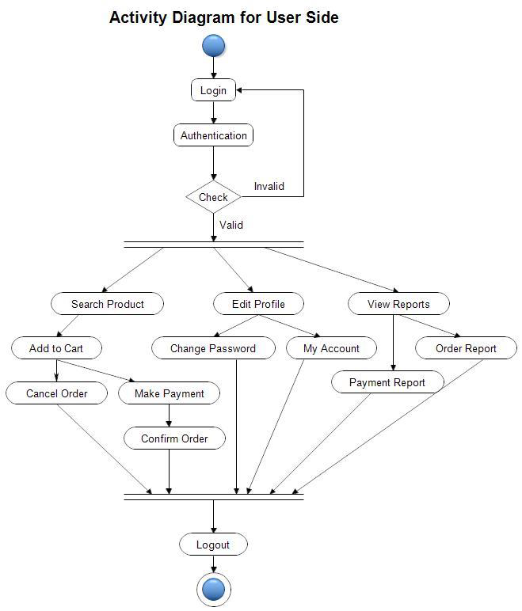

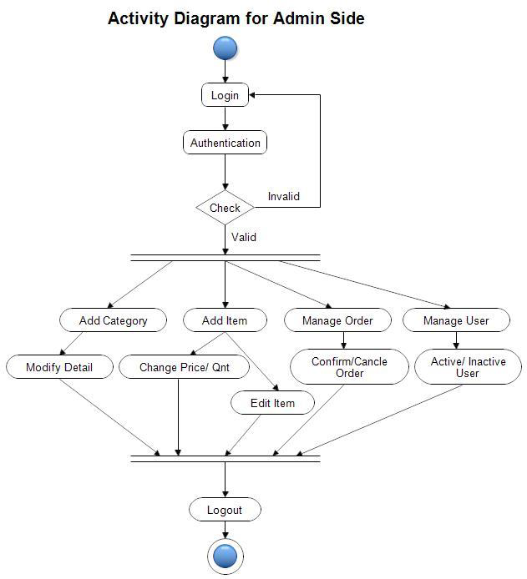

* 1. **Collabration diagram**
* This interactive behavior is represented in UML by two diagrams known as Sequence diagram and Collaboration diagram. The basic purpose of both the diagrams are similar.
* Sequence diagram emphasizes on time sequence of messages and collaboration diagram emphasizes on the structural organization of the objects that send and receive messages.

